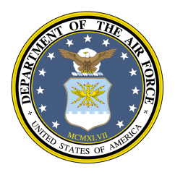
FACT SHEET 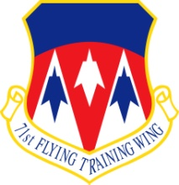

Vance Air Force Base, Oklahoma

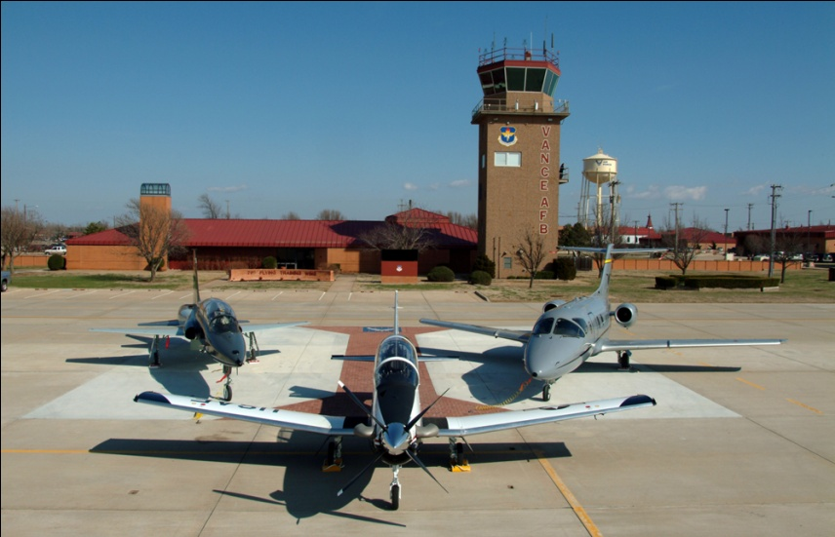

LOCATION
90 miles north by northwest of Oklahoma City at Enid, Okla.; elevation of 1,307 feet above sea level; northernmost Joint Specialized Undergraduate Pilot Training base in Air Education and Training Command.
PHYSICAL FACILITIES
Besides family housing, there are 136 buildings and 344 facilities on Vance as of March 2011. Additionally, Vance has 242 housing units - 125 officer family units, 117 enlisted family units, 309 unaccompanied units, 62 visitor units, and 10 temporary lodging units. The base is approximately 2,122 acres, which includes fee-owned land and easements. Kegelman Auxiliary Field is 1,066 acres with seven buildings and 40 facilities, and is located near Jet, Okla.

BASE POPULATION
Vance has 1,252 active duty and Reserve military, as well as approximately 1,335 family members, living here. The base also employs more than 1,380 Federal civilian employees, non-appropriated fund civilian employees, contractors and private business employees. There are an estimated 2,000 retired military members in the local area.
ANNUAL FLYING HOURS AND SORTIES
The wing flew 56,355 sorties totaling 82,058 flying hours in the T-1A Jayhawk, T-6A Texan II and
T-38C Talon, trained 493 pilots and graduated 332 pilots in fiscal year 2010, with no Class “A” mishaps.

GENERAL REVIEW

The mission of the 71st Flying Training Wing is to develop professional Airmen, deliver world-class Joint Pilots and deploy combat ready warriors. As the Air Force’s only Joint Specialized Undergraduate Pilot Training Wing (JSUPT), Vance is responsible for training Air Force, Navy, Marine Corps and allied student pilots for worldwide deployment and Aerospace Expeditionary Force support. The wing reports through 19th Air Force to Air Education and Training Command.

JSUPT is divided into three phases that cover 52 weeks. Phase I (preflight) is 24 days long and is split into two units: five hours of ground training, including emergency procedures, aircraft operating limitations, checklist usage and local radio procedures; and 220.9 hours of academic training including aerospace physiology/human factors, T-6 systems, flying fundamentals and introduction to aerodynamics. As part of the joint primary training syllabus developed at Vance, water survival training was added to Phase I in April 1998.
Phase II (T-6) primary training is 90 flying training days (28 calendar weeks) long and split into 5 units: Contact, instrument, navigation, formation and low-level. These units include 50.6 hours of academic and ground training, including instruments, weather, navigation and mission planning; 48.3 hours of flight simulator training; and 86.8 hours of aircraft flying training.

Most Navy and Marine Corps students depart Vance after Phase II training to complete advanced training with the Navy. Some Vance students arrive for advanced training having completed Phase I and Phase II training at Naval Air Station Whiting Field, Fla. These students flew the Navy’s T-34 Turbo Mentor during Phase II training.
Phase III fighter-bomber track (T-38C) advanced training is 120 days long and is split into five units: 60 hours of ground training, 80 hours of academic training, including T-38C systems, aerodynamics, flight planning, and an instrument qualifying examination; three hours of cockpit familiarization; 29 hours of simulator training; and 119 hours of aircraft flying training.
Phase III tanker-airlift track (T-1A) advanced training is 120 days long and is split into five units: 10 hours of ground training; 140 hours of academic training, including T-1A systems, aerodynamics, instruments and an instrument qualifying examination; three hours of cockpit familiarization; 42 hours of simulator training; and 87 hours of aircraft flying training.

In addition to primary flight training, Vance is home to the 3rd Fighter Training Squadron, whose mission is to give recent graduates who have been selected to fly fighters an introduction to fighter fundamentals. These students have already earned their wings and will stay at Vance for an additional 2+ months until they transition to their next training, or assigned, base.

Vance Air Force Base is named for Lt. Col. Leon R. Vance, a local World War II hero and Medal of Honor recipient. Originally, a flight school that trained more than 9,000 pilots for the Army Air Corps between 1941 and 1945, the base was activated Jan. 13, 1948, within the Air Training Command of the newly formed Air Force.

Vance was the first base in AETC to have extensive civilian contractor support for base functions ranging from aircraft maintenance to fire department to child care services. The support contract began in 1960 with Serv-Air. Northrop Worldwide Aircraft Services assumed the contract in 1972 and then on Feb. 1, 2001 the support contract transferred to DynCorp Technical Services. DynCorp's contract was assumed by Computer Sciences Corporation in 2005 and they presently perform in that capacity.

POINT OF CONTACT
71st Flying Training Wing, Public Affairs Office, 246 Brown Parkway, Suite 120, Vance AFB, OK 73705-5028; (580) 213-7476

Current as of March 2011

