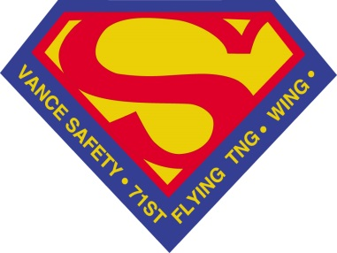
71ST FLYING TRAINING WING SAFETY OFFICE (71FTW/SE)
The 71st Flying Training Wing Safety office supports the 71st Flying Training wing's mission of developing professional Airmen, delivering world-class pilots and deploying combat ready warriors, through flight, ground and weapons safety programs. Its three main divisions are flight, ground and weapons safety.
The 71st Flying Training Wing Safety is located at 204 Thompson, Ste. 101, Vance AFB, OK 73705, or call (580) 213-7233.

  Safety - Flight Safety
  The flight safety division supports the wing's mission to train world-class pilots for the Air Force and numerous allied nations by advising the wing, groups, and unit commanders on all flight safety issues. Flight safety designs and executes flight safety programs that identify and manage hazards. The department programs include, among others: Bird Aircraft Strike Hazard Program (BASH); Mid-Air Collision Avoidance Program (MACA) and flight mishap investigation.
  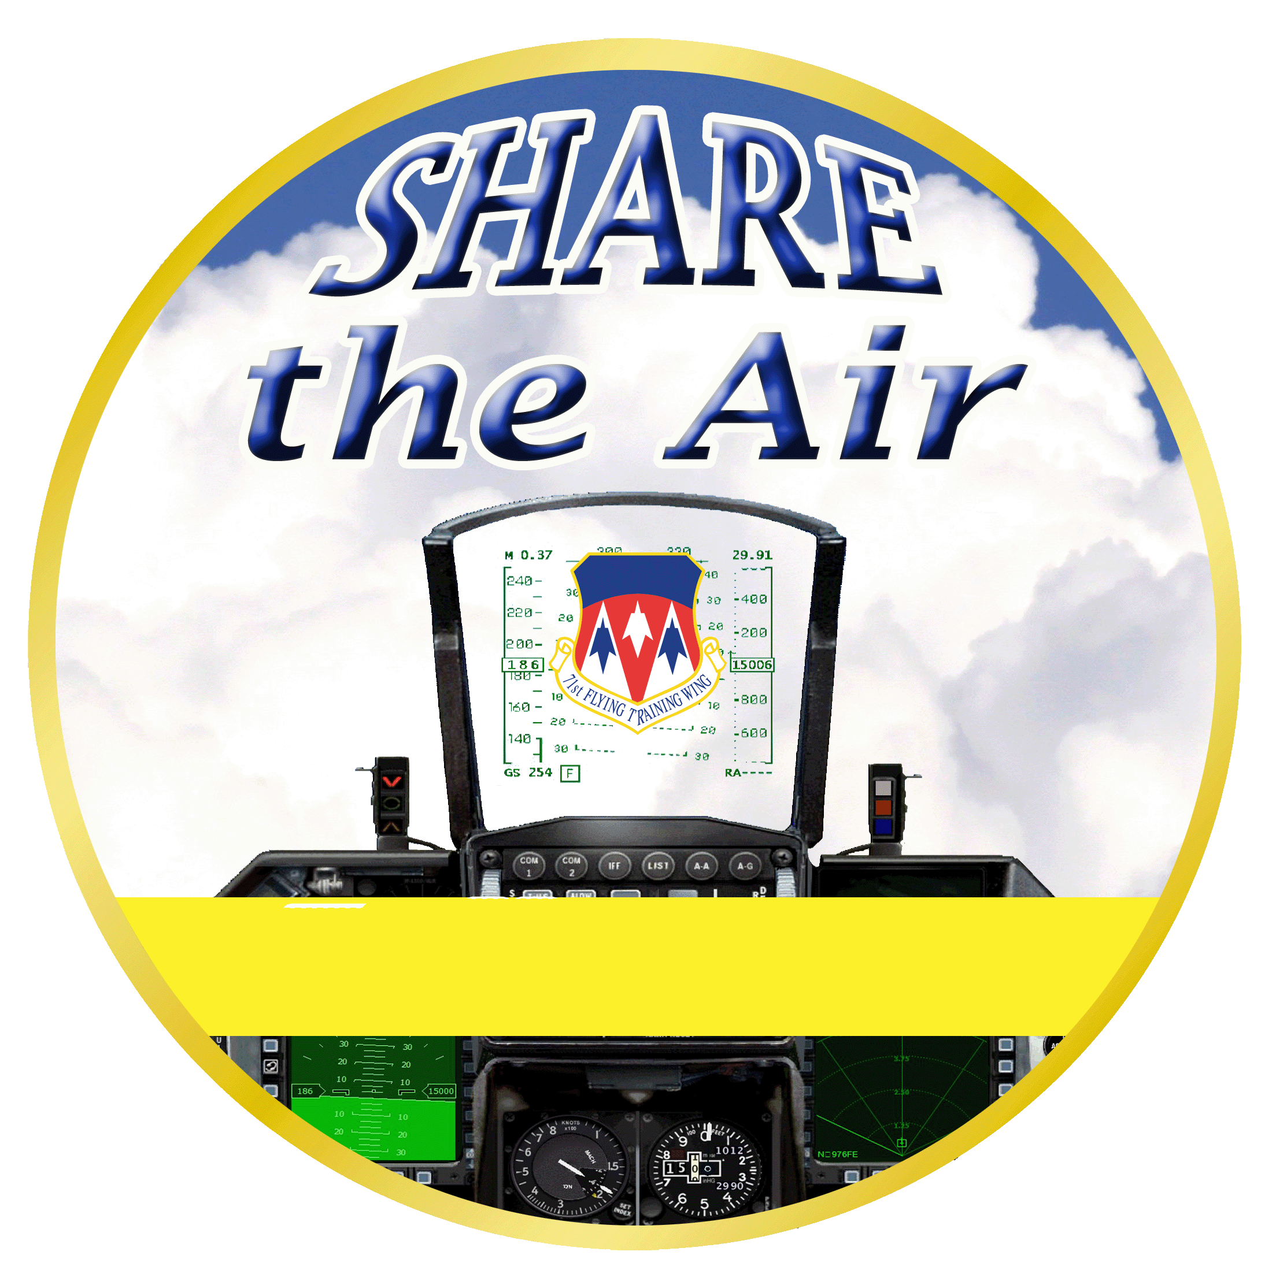
  Safety - Weapons Safety
  The weapons safety division establishes and executes mishap prevention programs for all nuclear and conventional weapons systems. The division provides nuclear systems design certification, explosives safety standards development and siting reviews, weapons safety consultation, as well as system inspection, oversight, education, explosives hazard classifications and staff assistance in its areas of responsibility.
  Safety - Ground Safety
  As part of the three tiered Wing Safety program, ground safety supports the overall vision to have a Wing Safety program, professionals, and culture that are fully prepared for mishap response, provide robust mishap investigation support, proactively identify risks and trends, and support commanders' ability to proactively identify, manage, and mitigate risks within their units. Ground safety also supports the Wing's mission while preserving resources by informing, equipping, and supporting commanders in their responsibility and effort to mitigate risks and prevent mishaps.

